|  |  |
| --- | --- |
| **[Project] – External Document** |  |
| <COMP6681001>  <Web Programming> |
| [Odd] Semester Year 2022/2023 |

* Project Title

MovieList

* Introduction

a website that displays a list of films or movies and actors who play a role. There are 3 types of views on the website. It is user, guest, and admin. Users who have accounts can add movies to the wishlist feature and have a profile. Guest can see home page, actor and, movie. Meanwhile, Admin can add actors and movies as well as edit actors and movies.

* Report / Documentation

1. Login Page
2. Register Page
3. User View

- Home Page



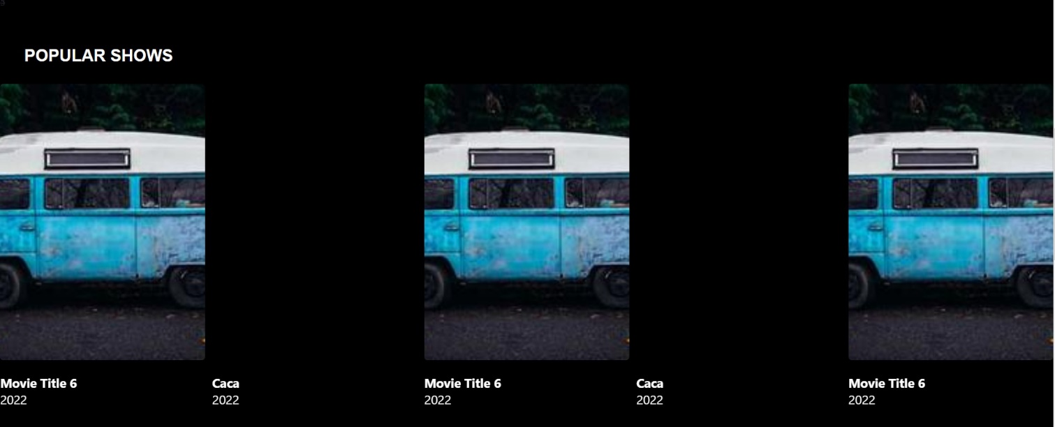

- Movie Page

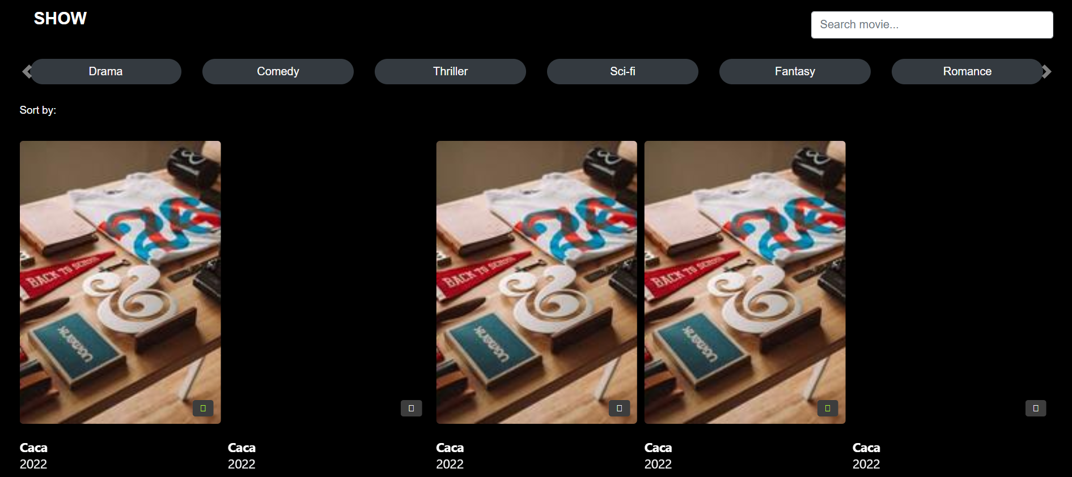

- Movie Detail Page

- Actor Page

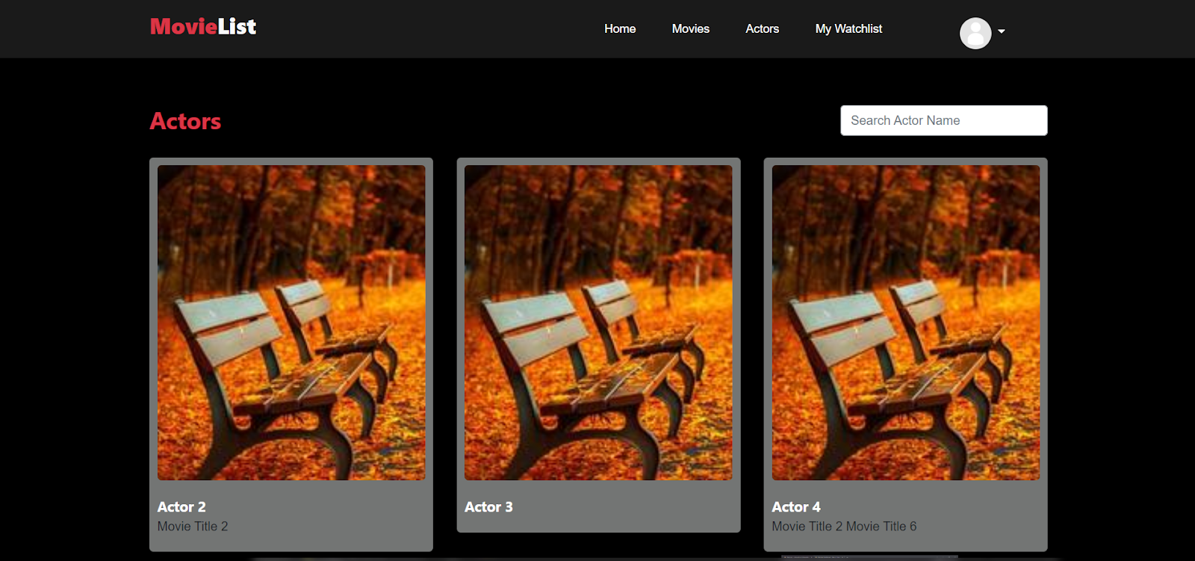

- Actor Detail page

- Watchlist Page

- Profile Page

1. Admin View

- Home Page



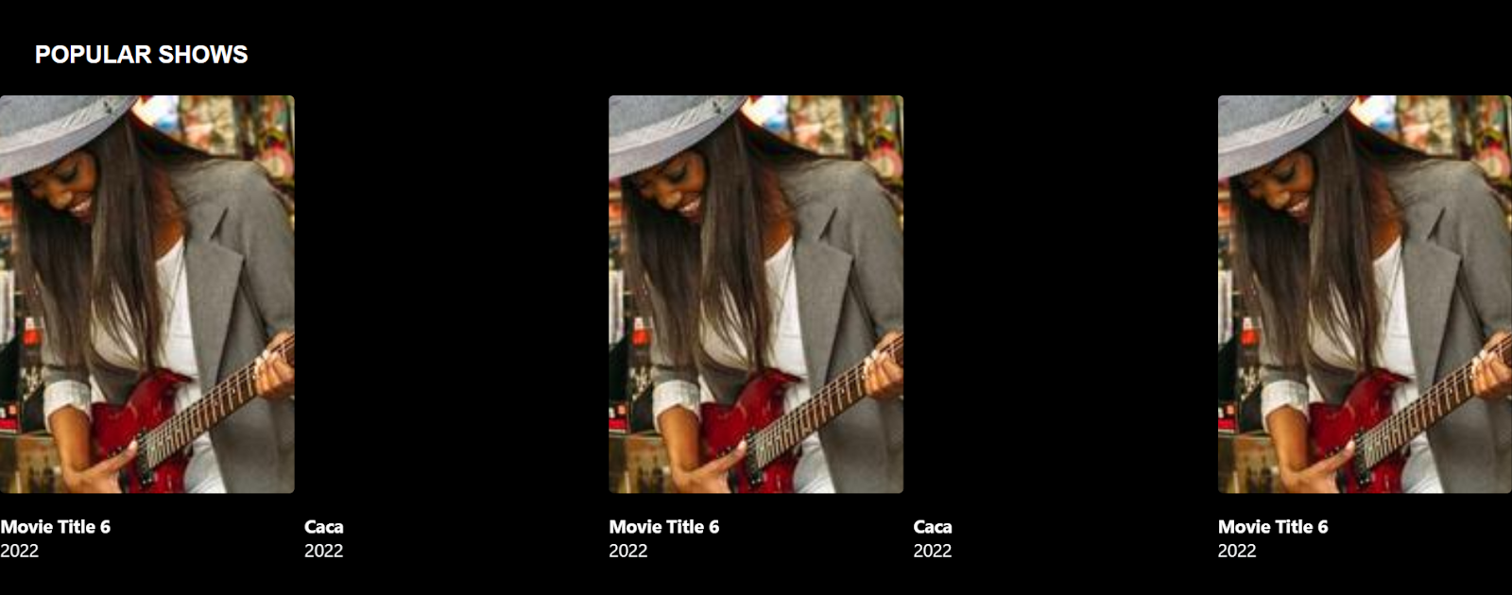

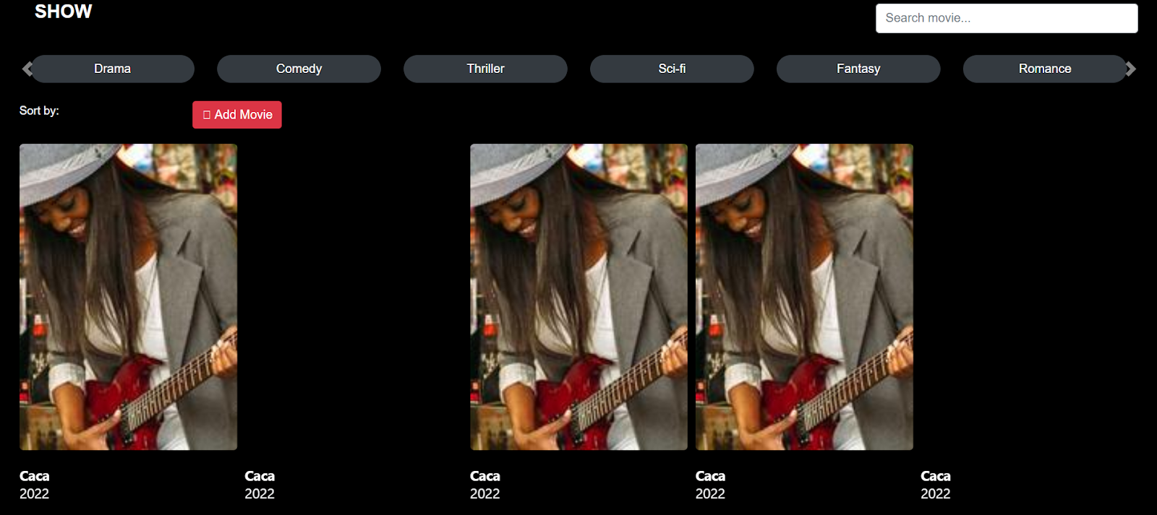

- Actor Page

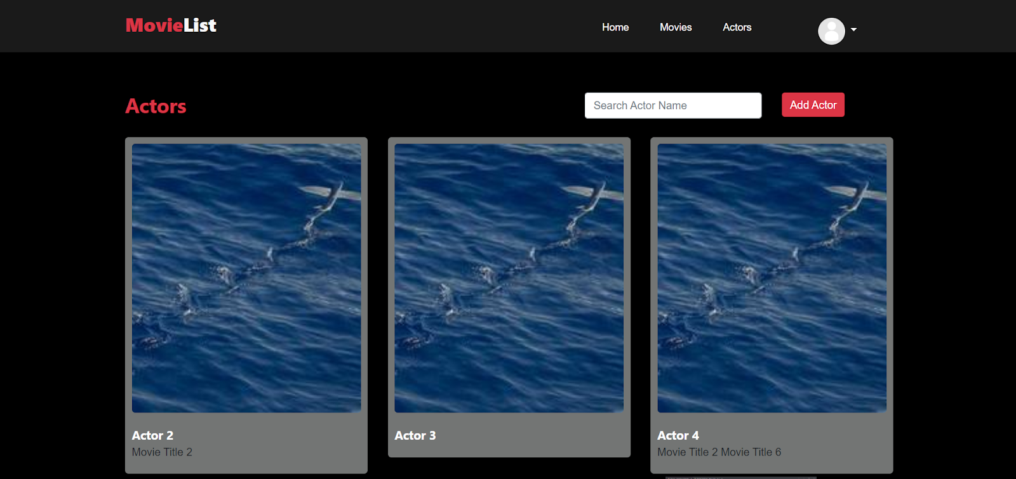

- Actor Detail Page

- Add Actor Page

- Movie Page

- Movie Detail Page

- Add Movie Page

- Profile Page

1. Guest View

- Home Page



- Actor Page

- Actor Detail page

- Movie Page

- Movie Detail Page

* Reference
* <https://getbootstrap.com/>
* Group Member
* 2440122564 – Angelique Aurielle Alpaullivarez
* 2440112033 – Salsabila Adrian